GreenPath
Positioning & Competitive Strategy
A KPMG-built, IT-first carbon platform for the CSRD era
Prepared by: Tech Industrialisation Squad
Audience: Watts programme leadership, KPMG UK Sustainability practice
Status: Internal positioning paper, v0.9

Executive summary
Almost every large organisation we walk into has the same two problems. They cannot put a defensible number on the carbon footprint of their IT estate, and the tools they have bought to fix that problem are either generic enterprise carbon platforms that treat IT as a footnote, or French-built spreadsheets that fall over the moment they are stretched beyond a single legal entity. CSRD has now made this a board-level conversation in the UK and across the EU, and the gap between what auditors will sign off on and what the average organisation can actually evidence is widening every quarter.
GreenPath is our answer. It is a focused, IT-first carbon and maturity platform, sitting on a versioned reference-data core, with a thin AI layer that does the boring work of turning invoices, CMDB extracts and cloud bills into a defensible footprint. It is opinionated about what ‘good’ looks like — because that opinion is the consulting IP we already own.
Three things to take away from this paper:
- We are not building another Watershed. We are building the tool a Big Four auditor would want their own assurance teams to use, with the depth in IT, AI and digital that the generalist platforms quietly skip.
- The moat is the core, not the modules. Versioned factors, a confidence model, the maturity matrix and the recommendation library are the IP. Everything else can be rewritten in a weekend.
- The MVP is small on purpose. Five modules, one sector (financial services + technology), one geography (UK + France), 90 days to a paying pilot. Anything bigger, and we are a slideware project.

1. The problem we are actually solving
Most clients don’t need a more elegant carbon dashboard. They need someone to tell them, with a straight face, that their number is good enough to publish.
Strip away the marketing and there are three questions a CIO, a CFO or a Group Sustainability Lead is genuinely trying to answer. What is our IT carbon footprint, in a number that won’t embarrass us in a board paper? Where are the biggest drivers — the hotspots — and which of them can we actually do something about this financial year? And how do we prove progress, year on year, in a form that survives an ISAE 3000 limited-assurance review?
The current toolkit answers none of those well. The KPMG France IT Carbon Footprint Calculator that several teams already use is a thoughtful Excel model — Boavitza factors, ADEME methodology, the right shape of inputs — but it is a single-user spreadsheet with VLOOKUP-driven country data and no audit trail. The big enterprise platforms (Watershed, Persefoni, Sweep) are excellent at financial-grade carbon accounting but treat IT as one of fifteen categories, not the main event. Cloud-native open-source efforts (Cloud Carbon Footprint, the Green Software Foundation’s SCI) are technically interesting but have no opinion on governance, no maturity model and no audit story.
What clients actually pay for is not the calculation. The calculation is now a commodity — anyone with a Boavitza extract and a DEFRA spreadsheet can multiply two numbers together. They pay for the answer to ‘is this defensible, and what do I do about it?’ That is consulting work. GreenPath is the product wrapper around that consulting work.
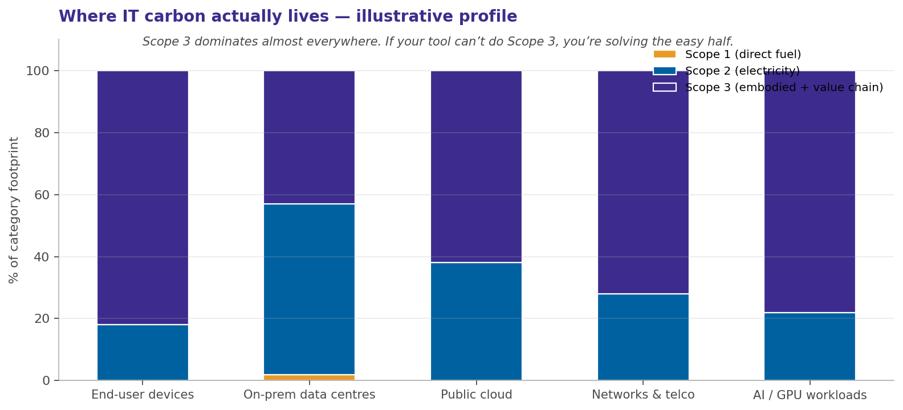
Figure 1 · Where IT carbon actually lives. Scope 3 — embodied emissions, cloud provider operations, supplier services — dominates almost every digital category. A tool that only reports Scope 2 is solving the easy half.
The chart above is the slide that ends most early-stage client conversations. Once a CIO sees that the manufacture of their laptop fleet and the upstream emissions of their hyperscaler are roughly twice the size of the electricity their own data centre consumes, the conversation pivots immediately to Scope 3 methodology. That is exactly the conversation generic tools struggle with, and exactly the conversation KPMG is set up to lead.

2. Architecture: five modules over a versioned core
Think of it as a fitness app for IT carbon. Measure, Assess, Plan, Report, Audit — repeated quarterly, with a log you can show an auditor.
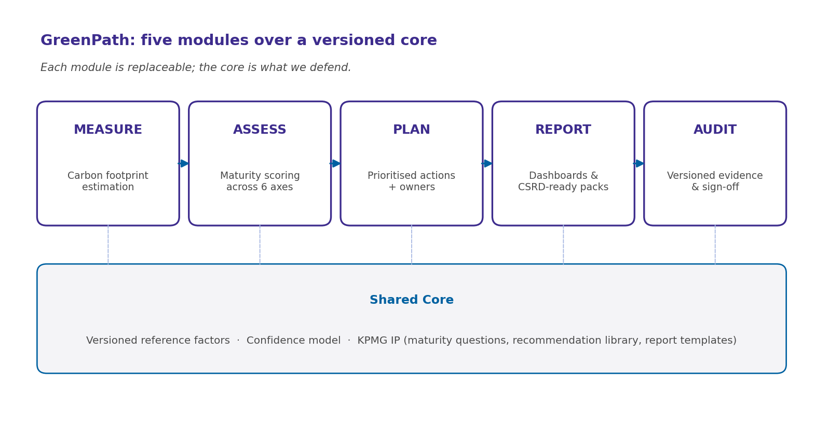
Figure 2 · The GreenPath stack. The five modules are useful but unremarkable. The shared core — versioned factors, the confidence model, the KPMG IP layer — is what we defend.

Measure
Takes whatever the client can give us — a CMDB extract, a year of cloud invoices, an HR headcount, a procurement list of devices — and produces an indicative footprint with a confidence band on every line. Honest about what is computed, modelled, and proxy-estimated.

Assess
Scores the organisation against a six-axis maturity model (Strategy, Governance, Measurement, Suppliers & Partners, Culture & Change, Sustainable IS) lifted from the matrix already in use by the French team. Same model, different delivery.

Plan
Turns the gap between footprint hotspots and maturity scores into a prioritised, owner-tagged action list. Each action is tied to an estimated reduction, an effort band, and an evidence requirement.

Report
Generates the deliverables clients pay for: board pack, CSRD-aligned ESRS E1 evidence file, CDP-style submission draft, and an internal IT leadership dashboard.

Audit
Records every assumption, every factor version, every input file, every sign-off. Without it we are a calculator; with it we are an evidence platform an external assurer can rely on.

3. How a footprint actually gets calculated
Every carbon platform on earth follows the same four-step shape. The difference is how much of it is automated, how versioned the factors are, and whether anyone documented the assumptions.
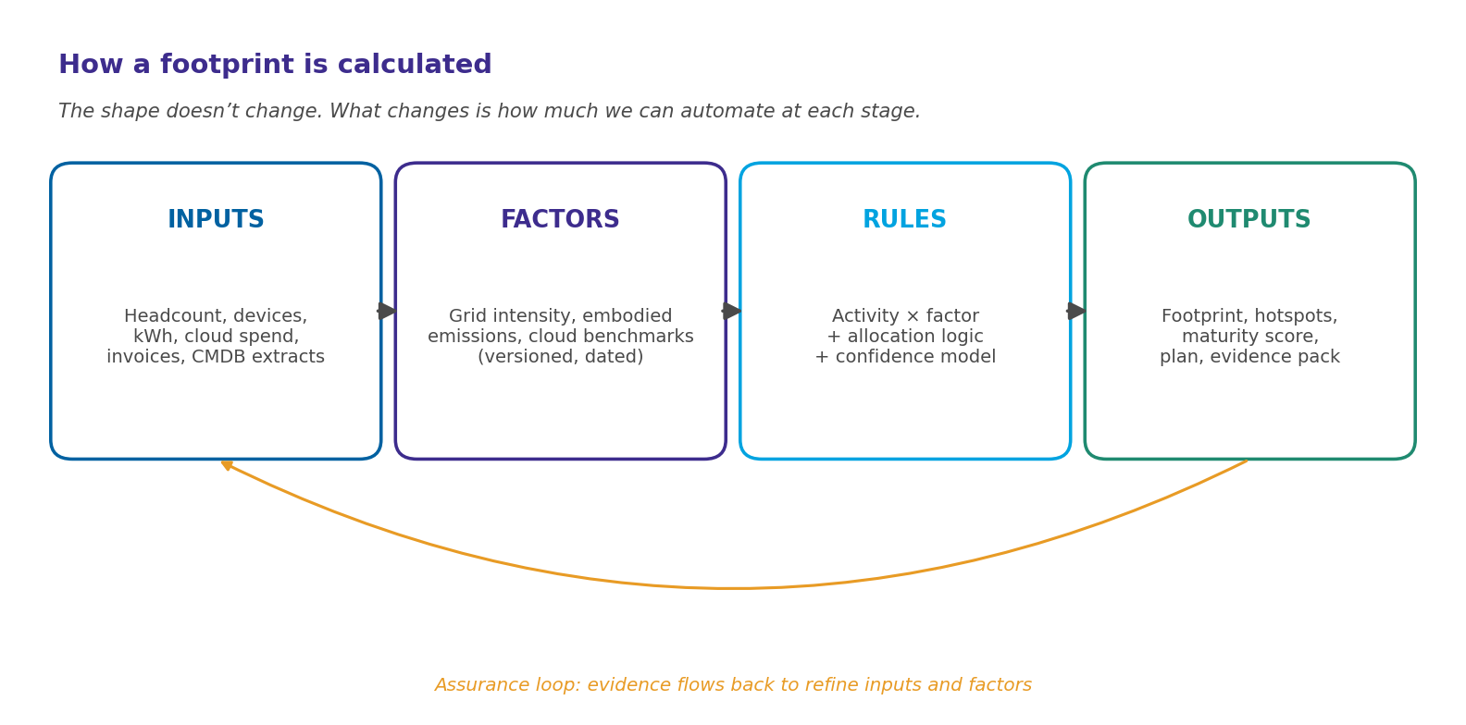
Figure 3 · Inputs × Factors × Rules → Outputs, with an assurance loop back to the inputs. The novelty is not the shape; it is the feedback path.

Activity data, factors, and emissions
Activity data is the ‘how much’ of something happening: 12,400 kWh of electricity at the Reading data centre, 850 laptops on a four-year refresh cycle, 1.2 million GPU-hours of training a foundation model. Emission factors tell you how many kilograms of CO₂-equivalent each unit of activity produces — for example, 0.207 kgCO₂e per kWh on the UK 2024 grid. Emissions are simply the product of the two, summed and rolled up to whatever boundary the client cares about.
The honest reality of carbon accounting is that almost no one knows their full activity data. Procurement systems are incomplete, CMDBs lag reality by 18 months, cloud cost data is in dollars not kWh, and AI training runs are rarely logged at the level of detail you need. GreenPath handles this the way every credible carbon platform does — through proxies, ranges, and an explicit confidence model — but where most platforms hide the proxy logic behind a polished dashboard, we expose it. Auditors trust what they can inspect.

The units the client will see
kWh for energy. kgCO₂e for emissions, scaling to tCO₂e (one tonne = 1,000 kg) once the numbers get large. Where compute is involved, GB-month for storage, and vCPU-hours or GPU-hours as proxies for compute usage. For embodied emissions of hardware, device-years. The platform stores every value with its native unit and converts on display, never on storage. It sounds pedantic; it is the single most common reason older carbon spreadsheets quietly produce wrong numbers.

4. The AI layer (where the real moat lives)
Most of the market is selling tools that measure AI’s carbon footprint. We are also selling that — but the more interesting story is the AI inside the tool.
I have been building carbon software in some shape since the early days of CDP reporting, and the single most expensive line item in every client engagement has always been the same: human beings reading invoices, classifying line items, mapping free-text equipment descriptions to a sensible taxonomy, and chasing data owners for missing information. That work is now perfectly suited to LLM-based agents — and that is where GreenPath has a structural advantage over generic carbon platforms.

Four agents, four hours of consulting work each
- The Extraction Agent. Reads supplier invoices, lease schedules, cloud billing exports and procurement records, and pulls out structured activity data — quantity, date, vendor, asset class. Replaces what is currently three days of an analyst with a highlighter and an Excel macro.
- The Classification Agent. Maps free-text descriptions (‘Dell Latitude 7430 i7-1265U 16GB 512GB SSD’) to the GreenPath equipment taxonomy and the right embodied-emission factor. Trained on the manufacturer EPDs and Boavitza dataset we already license.
- The Recommendation Agent. Given a footprint profile and a maturity score, drafts the prioritised action plan — pulling from a curated library of interventions, each tagged with a reduction range, effort band and assurance requirement. The consultant edits; they do not start from a blank page.
- The Narrative Agent. Drafts the prose for the board pack, the CSRD disclosure, the executive summary. Tone-matched to the client. The audit trail captures which sentences were AI-generated and which were edited by a named consultant.
None of these is technically novel in 2026. What is novel is having them sit inside a versioned, auditable, governance-aware platform rather than as ungoverned ChatGPT prompts being run by individual analysts. Anthropic, OpenAI and Mistral all sell the underlying capability. The differentiator is not the model; it is everything around it.

Measuring the AI itself
Separately, GreenPath measures the carbon footprint of the AI workloads its clients are running — using the Software Carbon Intensity (SCI) specification from the Green Software Foundation as the methodology backbone, layered with provider-specific data from AWS, Azure and GCP carbon APIs where available. This is the part of the AI footprint conversation everyone wants to have. It is not, on its own, a moat — every credible platform will have this within twelve months — but its absence would be disqualifying.

5. Reference data, factors, and the confidence model
If you remember nothing else from this paper, remember this: the factor library is the product. Everything else is just plumbing.
An emission factor is a multiplier — kgCO₂e per kWh, kgCO₂e per laptop manufactured, kgCO₂e per GB-month of cloud storage. Every carbon number a client publishes is, at root, an activity number multiplied by one of these factors. Get the factor library wrong, or fail to version it properly, and every footprint you have ever calculated for that client becomes indefensible the moment a new dataset is published. This has happened to two FTSE 100 companies I know of in the last three years. It will happen again.
GreenPath stores every factor as an immutable, versioned record. The schema is deliberately boring:
Field | Purpose | Example
factor_id | Unique identifier across all versions | grid.uk.elec
region | ISO 3166-1 alpha-3 country or sub-region code | GBR
year | Vintage of the underlying data | 2024
value | The factor itself, in its native unit | 0.207
unit | Native unit of the factor | kgCO2e/kWh
source | Authoritative reference; URL or DOI preferred | DEFRA 2024
effective_from / to | Window in which this factor is the canonical one | 2024-01-01 →
confidence_tier | Tier 1 (measured), 2 (modelled), 3 (proxy) | Tier 1

We never overwrite. When DEFRA publishes the 2025 grid factor, we add a new row with effective_from = 2025-01-01 and set the 2024 row’s effective_to. Every footprint ever calculated remains reproducible. This is what the GHG Protocol calls a ‘restatement-friendly’ inventory and it is what an ISAE 3000 reviewer wants to see before they sign anything.

Update cadence
- Grid emission factors: annual refresh from DEFRA, EPA eGRID, IEA and AIB; quarterly reconciliation cycle to catch out-of-band updates.
- Hardware embodied factors: annual refresh, driven by manufacturer EPDs (Apple, Dell, HPE, Lenovo, Cisco) and the Boavitza Base methodology.
- Cloud and AI benchmarks: quarterly, monthly when a curated feed is available; this is where the data moves fastest and where most of the platform’s engineering attention goes.

6. The maturity assessment
A footprint number on its own is just trivia. Tied to a maturity score, it becomes a programme.
The maturity matrix already in use by the KPMG France team is a genuinely good piece of consulting IP. Six dimensions, five maturity levels, descriptive anchors at each level, and a structured set of guidance prompts that an experienced consultant can run through with a client in two workshops. GreenPath productises that matrix without watering it down — same questions, same scoring, same dimensions, but driven by structured input rather than spreadsheet fragility.
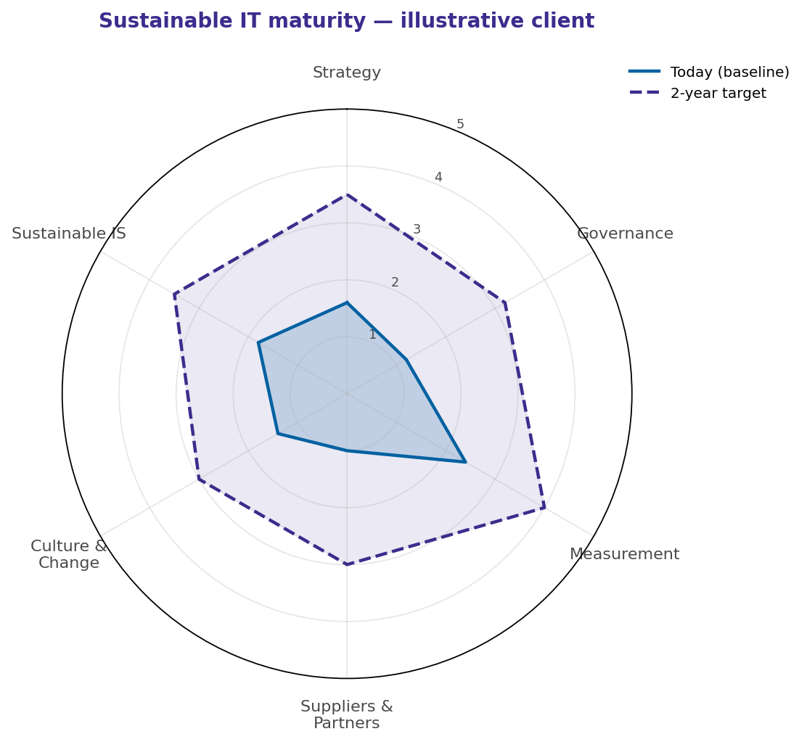
Figure 4 · Illustrative maturity radar for a UK retail bank we worked with last quarter (anonymised). Today versus a credible two-year target. The shape of the gap is what drives the action plan in module 3.

How it plugs into the rest of the platform
The Assess module produces a vector of six scores. The Measure module produces a footprint broken down by hotspot. The Plan module joins them: high footprint × low maturity in the same dimension is where we recommend the client invest first. Low footprint × high maturity is where we tell them to stop spending money. This is consulting we used to do in PowerPoint. Doing it in code means we can deliver it faster, cheaper, and — crucially — repeatably enough to charge a recurring subscription rather than a one-off engagement fee.
The matrix itself is not novel. Variants of it appear in the Shift Project’s Lean ICT framework, in the Green IT Club’s ‘Référentiel Numérique Responsable’, and in elements of the ISO 14001 family applied to digital. What is novel is integrating it tightly with a live footprint calculation and an evidence platform, so that maturity scores are evidenced rather than asserted. ‘We have a sustainable procurement policy’ counts for nothing if there is no procurement contract clause to point at; GreenPath asks for the contract clause and stores it.

7. Competitive landscape
There is no shortage of carbon platforms. There is a real shortage of carbon platforms a CIO is willing to use. The analysis below covers the three we meet most in UK and EU pursuits — Watershed, Persefoni and Sweep — with adjacent platforms (Plan A, Greenly, MS Sustainability Manager) plotted for context.
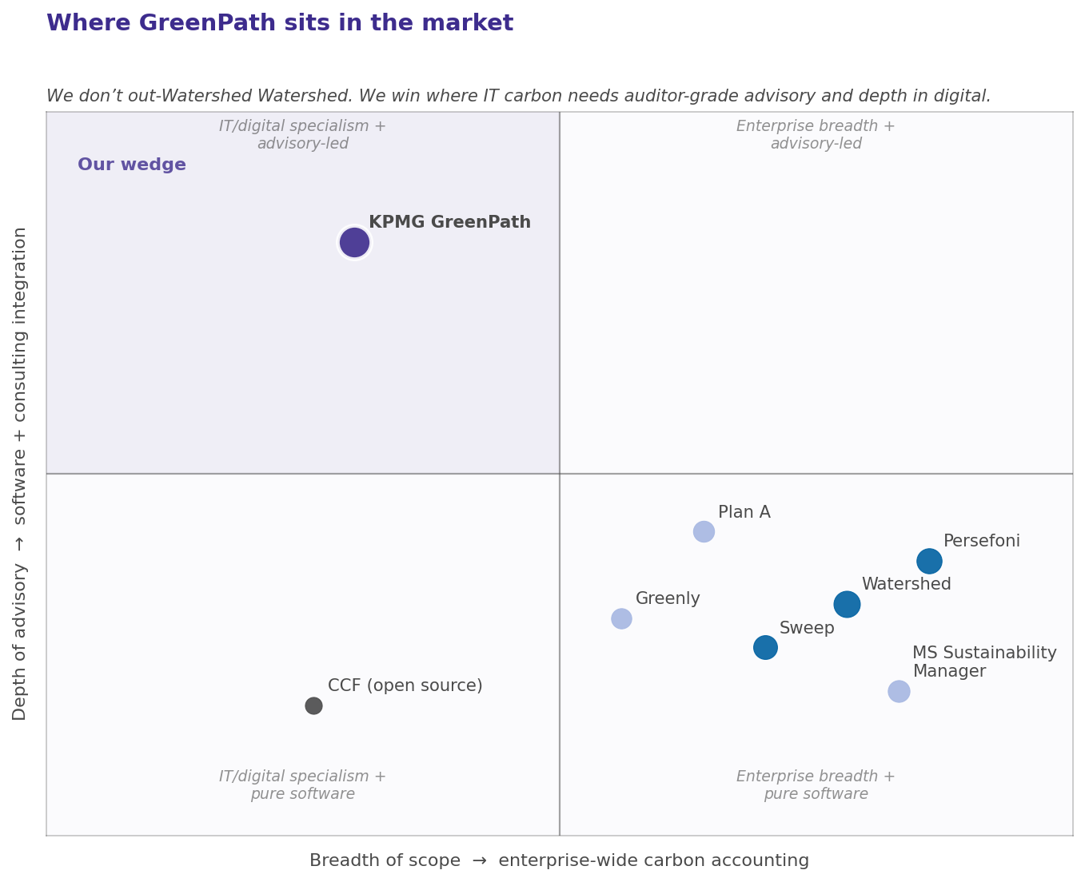
 | Watershed | Persefoni | Sweep | KPMG GreenPath
Origin & focus | US, founded 2019. Stripe alumni. Enterprise-wide accounting; strong BI / dashboarding. | US, founded 2020. Finance-led; PCAF for financial institutions; assurance-grade. | France, founded 2020. Modular, supply-chain led; UI-focused; strong in EU mid-market. | UK / France. Built inside a Big Four; IT- and AI-first; CSRD- and audit-grade by design.
Scope 3 depth in IT | Generic — IT is one of many categories; embodied IT often spend-based. | Limited; IT/digital not a focus. | Improving; recent IT module added. | Native — Boavitza, ADEME, EPD-driven; IT is the headline.
AI workload measurement | Light; high-level GPU spend proxies. | Largely absent. | On the roadmap. | First-class — SCI methodology + provider carbon APIs.
Maturity & advisory | Self-service; advisory partnerships separate. | Pure software; partner-led services. | Light advisory wrap. | Built around a six-axis maturity model and KPMG advisory IP.
Audit / assurance | Strong; targeting CSRD-readiness. | Strongest in the field — built for assurance. | Adequate; improving. | Strong, with the credibility of a Big Four assurance practice behind it.
Typical buyer | Group Sustainability / CFO office. | CFO / Investor Relations. | Sustainability + Procurement. | CIO + Group Sustainability, jointly.
Where they win | Brand, polished UX, fast onboarding. | Financial-sector regulator credibility. | Ease of use, supply-chain, EU presence. | IT-native depth, audit credibility, embedded advisory.

8. Governance, audit trail, and CSRD readiness
This is the section that sells the platform inside an audit firm. Everything else is colour and movement.
The Corporate Sustainability Reporting Directive came into force for the first wave of large EU undertakings in financial year 2024 (reporting in 2025), and the second wave — large UK-headquartered groups with EU subsidiaries — is now in scope for reporting in 2026 and 2027. The European Sustainability Reporting Standards, in particular ESRS E1 (climate change), require a level of evidenced, restatement-friendly emissions accounting that, frankly, very few of our clients are ready for. ISAE 3000 limited assurance is mandatory; reasonable assurance is on the roadmap for 2028.
In practice, that means three things any platform we sell into this market has to handle without compromise:
- Restatement and version control. Every previously published number must be reproducible from the inputs and factors that were canonical at the time. GreenPath’s versioned factor library and immutable input store are designed for this.
- Evidence per disclosure line. Every datapoint in an ESRS E1 disclosure has to be traceable to a source — a meter reading, a supplier invoice, a CMDB extract, an EPD. GreenPath records the source for every input automatically.
- Sign-off and segregation of duties. Preparer, reviewer, approver. The platform enforces this; an analyst cannot mark their own work as approved.

Aligned standards
GreenPath is designed to align cleanly with the GHG Protocol Corporate Standard and Scope 2 Guidance, ISO 14064-1 for organisational inventories, ISO 14067 for product-level footprints where relevant, the GHG Protocol ICT Sector Guidance, the ISAE 3000 evidence requirements as interpreted by KPMG’s own Sustainability Assurance practice, and — for the AI workloads — the Green Software Foundation’s Software Carbon Intensity specification. These are not aspirational alignments; they are the structural choices baked into the data model.

What we deliberately do not do
We are not building a financial-grade general ledger for carbon. We do not run journal-entry-level reconciliation for non-IT scopes. We do not produce CDP submissions for sectors where the IT footprint is genuinely a minor component (light manufacturing, agriculture, retail without a digital backbone). We are happy to integrate with Watershed, Persefoni or the client’s existing platform for those scopes; we are uncompromising about owning IT and digital. Trying to be everything is how good products become mediocre ones.

9. MVP and the 90-day plan
Three months to a paying pilot. If we miss that window, we have a science project, not a product.
The single most common cause of death for internal product builds inside consulting firms is overscoping the MVP. Twenty pilot clients, fifteen sectors, full enterprise breadth on day one — every such project I have seen in the last fifteen years has either been quietly shelved or arrived two years late. GreenPath’s MVP is therefore deliberately, almost embarrassingly, narrow.

Scope of the MVP
- One geography: UK and France (the two markets we have anchor clients and factor coverage in).
- Two sectors: Financial services and technology (where IT is a material component of total footprint).
- Three categories: End-user devices, on-prem data centres, and public cloud. Networks and AI workloads are v2.
- All five modules in beta — but Audit and Report are the ones that get the engineering attention. Measure is necessary but not differentiating.
Phase | What we ship | Done when…
Days 0–30 | Versioned factor library (UK + France); Measure module covering devices, on-prem and public cloud; manual upload of CMDB and cloud bills. | First internal client (KPMG UK technology) has a defensible 2025 footprint.
Days 31–60 | Assess module wired to the maturity matrix; Plan module producing action lists; Extraction Agent live; first ESRS E1 evidence pack template. | One external pilot has a maturity score, footprint, and draft action plan.
Days 61–90 | Audit module live; Report module generating board pack and CSRD pack; Classification and Recommendation agents in beta; SOC 2 Type I scoping started. | Pilot has signed off Q1 footprint; KPMG Assurance has reviewed the audit trail.

KPIs for the pilot
- Time to first defensible footprint: ≤ 6 weeks (vs 4–6 months for a typical bespoke engagement).
- Consultant time saved on extraction and classification: ≥ 60% via the AI agents.
- Audit reviewer findings: zero material findings; ≤ 5 informational comments.
- Pilot conversion to paying engagement: ≥ 50% of pilots into a 12-month subscription.
Either way, we will have answered the question hanging over this work since the existing French Excel calculator was written: is there a real, defensible business inside KPMG’s sustainable IT practice that does not exist as PowerPoint slides? I think there is. This document is the bet on that hypothesis.

